

UI Design Standards
For Wiseman Web Applications
(For Development and QA Team Use)

Created by:
Ahsan Khurshid
(Sr. UI/UX Designer & Developer)

Version 1.3

Typography:

Headings:
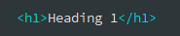
h1. Heading 1
Heading 1: Font Size: 36px | Font-weight: 400 | Font-Color: #333333 | Font-Family: Open Sans

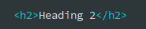
h2. Heading 2
Heading 2: Font Size: 30px | Font-weight: 300 | Font-Color: #333333 | Font-Family: Open Sans

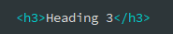
h3. Heading 3
Heading 3: Font Size: 24px | Font-weight: 300 | Font-Color: #333333 | Font-Family: Open Sans

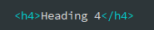
h4. Heading 4
Heading 4: Font Size: 18px | Font-weight: 300 | Font-Color: #333333 | Font-Family: Open Sans

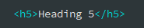
h5. Heading 5
Heading 5: Font Size: 14px | Font-weight: 600 | Font-Color: #333333 | Font-Family: Open Sans
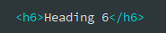

h6. Heading 6
Heading 6: Font Size: 12px | Font-weight: 600 | Font-Color: #333333 | Font-Family: Open Sans

Body:
Text Body Lead 1
Body Lead: Font Size: 18px | Font-weight: 400 | Font-Color: #333333 | Font-Family: Open Sans

HTML:
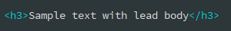

Text Body Lead 2
Body Lead: Font Size: 16px | Font-weight: 300 | Font-Color: #333333 | Font-Family: Open Sans

HTML:

Text Body
Body: Font Size: 14px | Font-weight: 400 | Font-Color: #333333 | Font-Family: Open Sans

HTML:
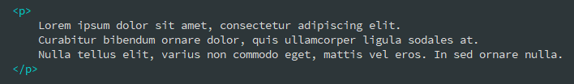

Unordered Lists:
Unordered Lists: Font Size: 14px | Font-weight: 400 | Font-Color: #333333 | Font-Family: Open Sans

- Lorem ipsum dolor sit amet
- Nulla volutpat aliquam velit
  - Phasellus iaculis neque
  - Purus sodales ultricies
- Aenean sit amet erat nunc
- Eget porttitor lorem

HTML:
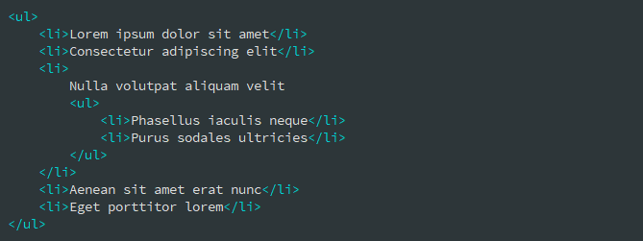

Ordered Lists:
Ordered Lists: Font Size: 14px | Font-weight: 400 | Font-Color: #333333 | Font-Family: Open Sans

- Lorem ipsum dolor sit amet
- Facilisis in pretium nisl aliquet
- Nulla volutpat aliquam velit

HTML:
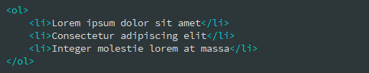

Description Lists:
Heading: Font Size: 14px | Font-weight: 700 | Font-Color: #333333 | Font-Family: Open Sans
Body: Font Size: 14px | Font-weight: 400 | Font-Color: #333333 | Font-Family: Open Sans

Description list Item 1
A description list is perfect for defining terms.

Description list Item 2
A description list is perfect for defining terms. Vestibulum id ligula porta felis euismod semper eget lacinia odio sem nec elit.
HTML:
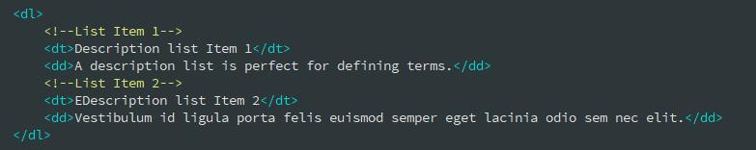

Text States:
Body: Font Size: 14px | Font-weight: 400 | Font-Family: Open Sans

Muted text here

Primary text here
Success text here
Danger text here

General Components:

Alerts:
Body: Font Size: 14px | Font-weight: 400 | Font-Family: Open Sans

Default Alerts:
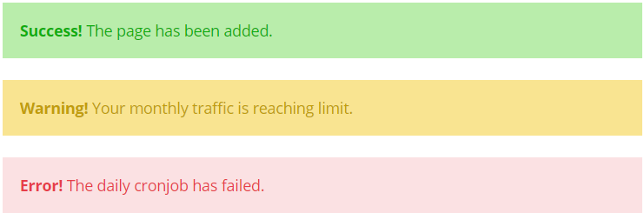

HTML: | CSS Class(es):
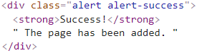 | alert-success  alert-warning  alert-danger

Dismissible Alerts (Same color variations as above with close icon):

HTML:
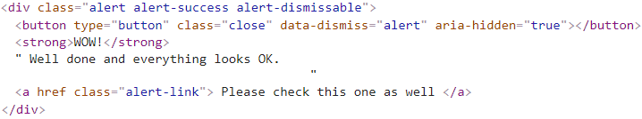

Button Styles:
Styles: Font-weight: 400 | Font-Family: Open Sans | Font-Size: 14px

Solid Buttons:
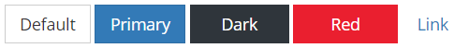

HTML:

CSS:
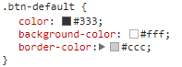 | 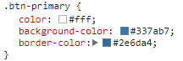
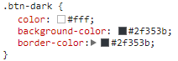 | 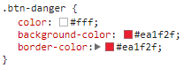
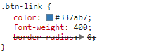

Outlined Buttons (Custom):

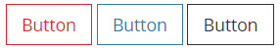

HTML:

CSS:
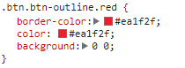 | 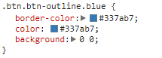
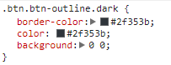

Window Dialog/Modals/Popups: Preview

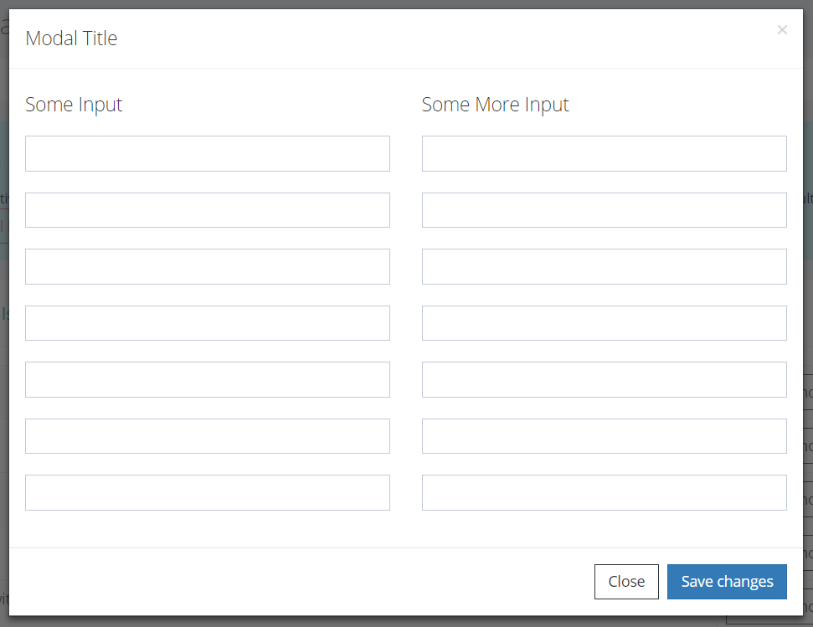

HTML:
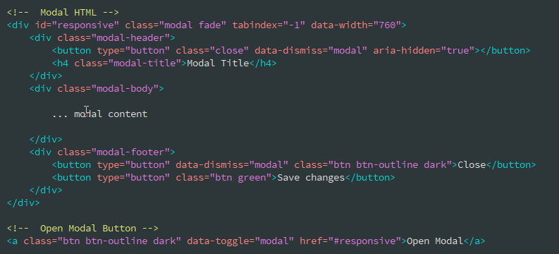
Form: Preview

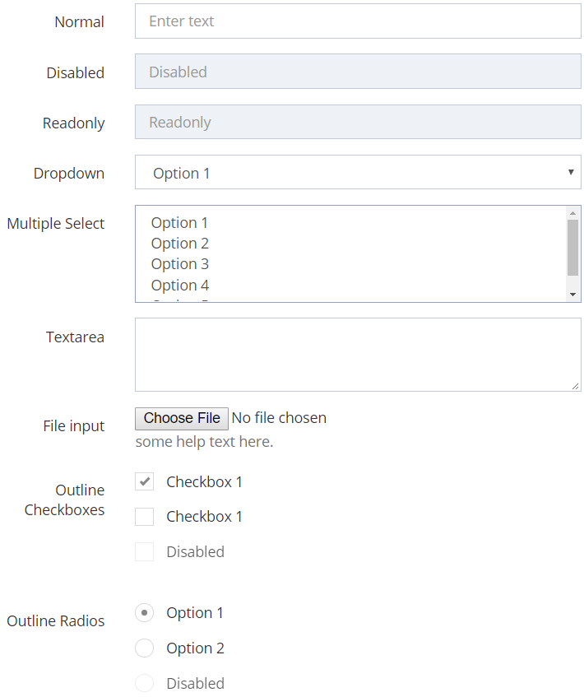

Preview
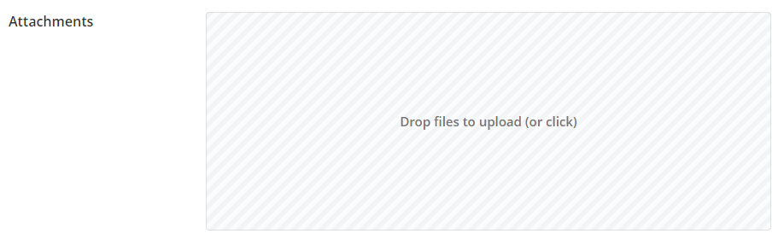
Normal Text Field with Label:

HTML:
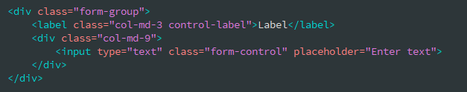

Disabled Text Field with Label:

HTML:
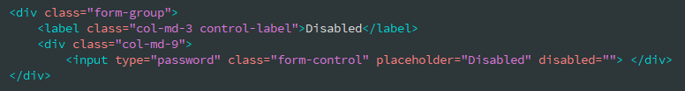

Readonly Text Field with Label:

HTML:
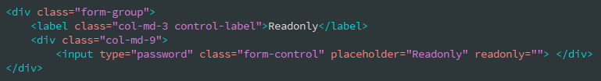

Dropdown with Label:

HTML:
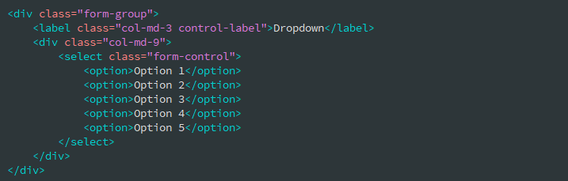

Multiple Select with Label:
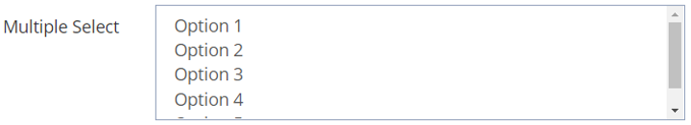

HTML:
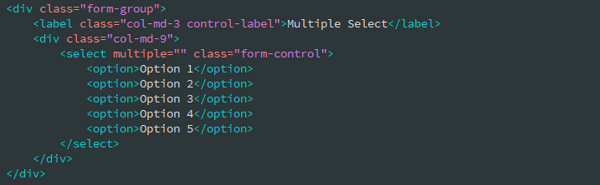
Textarea Field with Label:
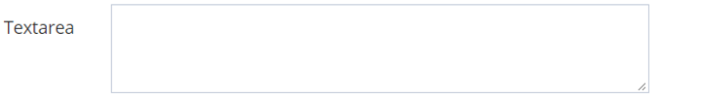

HTML:
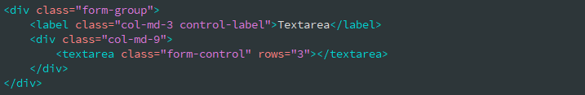

File Input Field with Label:

HTML:
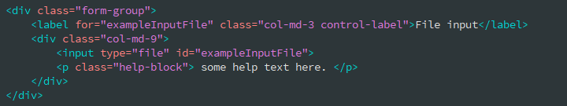

File Input Drop Zone with Label:

HTML:
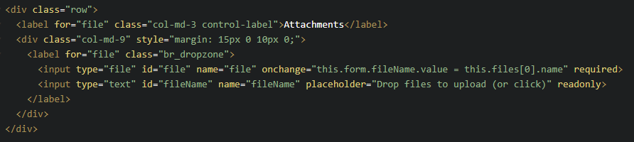

Checkboxes with Label:
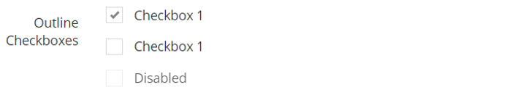

HTML:
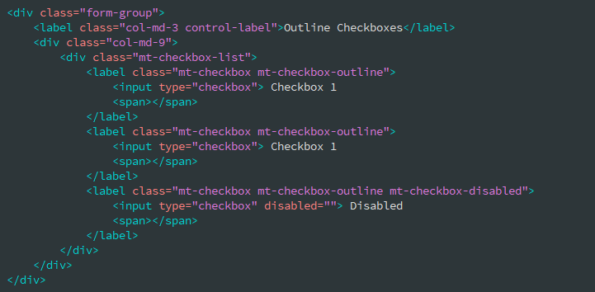

Radio Buttons with Label:


HTML:
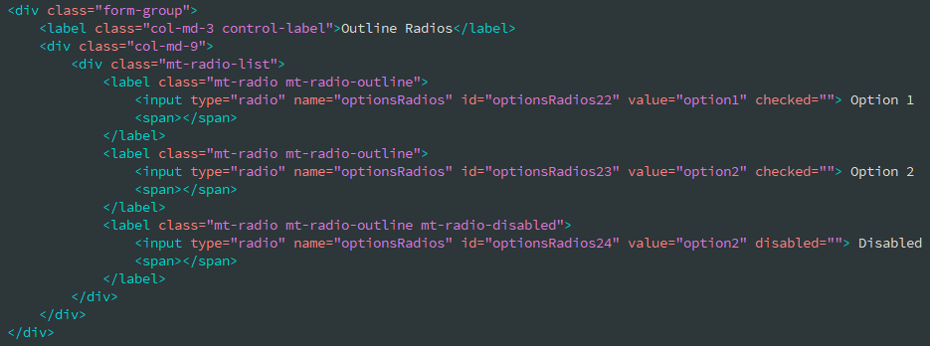

Form Validations:

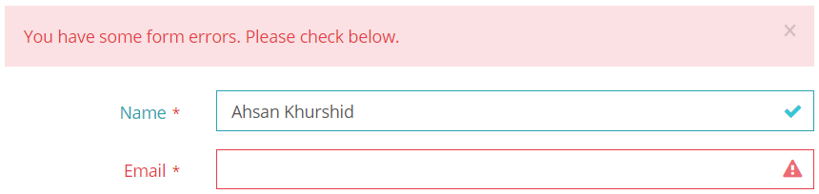

HTML (Input Fields):
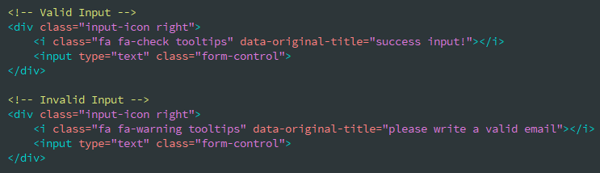

HTML (Dismissable Alerts):
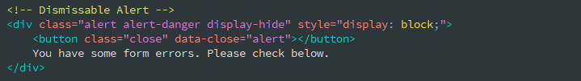

Accordions: Preview
Styles: Font-Family: Open Sans
Title-Font-weight: 300 | Title-Font-Size: 16px | Desc. Font-Weight: 400 | Desc. Font Size: 13px

Example 1:
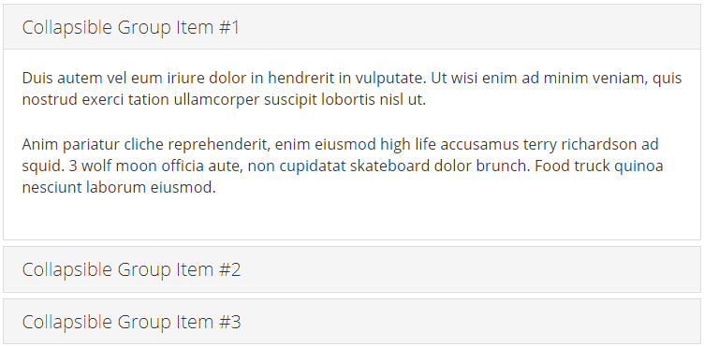

Example 2:
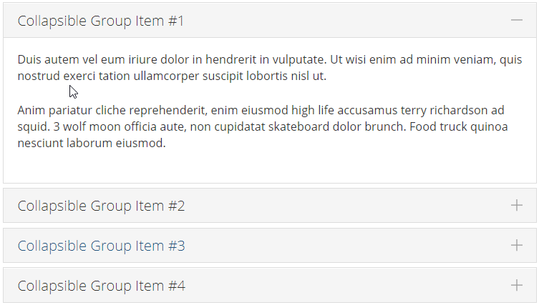

HTML:
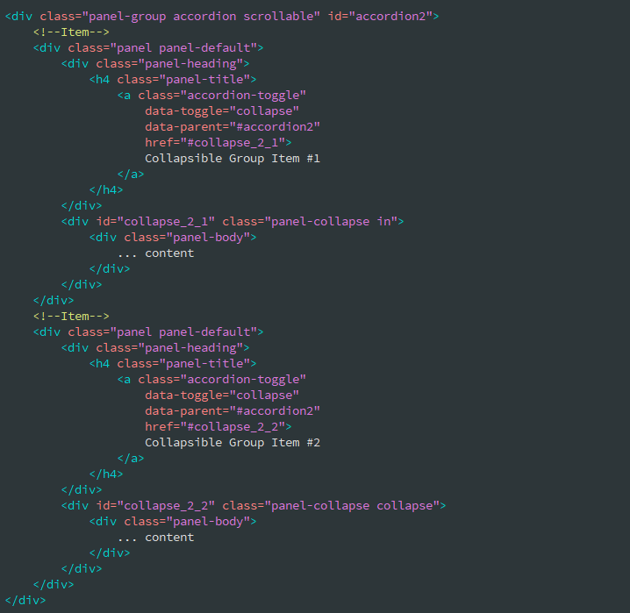

Add class “accordion-toggle-styled” for plus, minus icons as given in example 2 above:
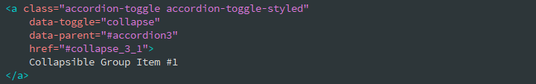

Tabs:
Styles: Font-weight: 400 | Font-Family: Open Sans | Font-Size: 14px

Default Tabs:

HTML:
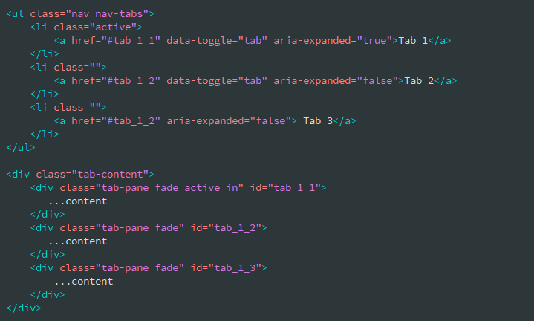

Large Number of Tabs Using Dropdown Menu:

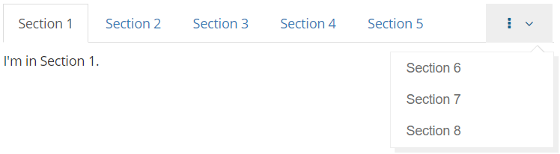

Notes: Add following code before Tab 1 <li> item to achieve above result. Also add “tab-pane” in tab-content section for each newly added list items.

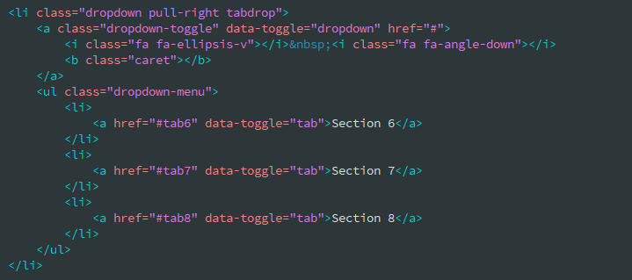

Left Styled Tabs:

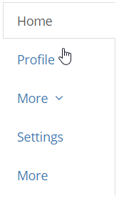 | Notes: To achive this add bootstrap row with two cloumns having following code:  Left Column: Add class “tabs-left” to make tabs left styled.  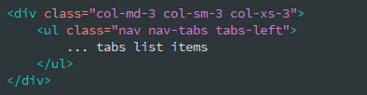  Right Column:  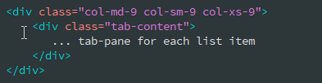

Right Styled Tabs:

Notes: To achive this add bootstrap row with two cloumns having following code:  Left Column: Add class “tabs-right” to make tabs right styled.  Rest code is same as above for left styled tabs. | 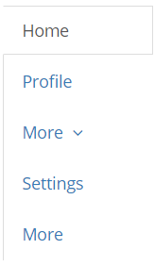

Reports:

Tables: Preview

Data Tables (Managed with Buttons, Pagination, Sorting)

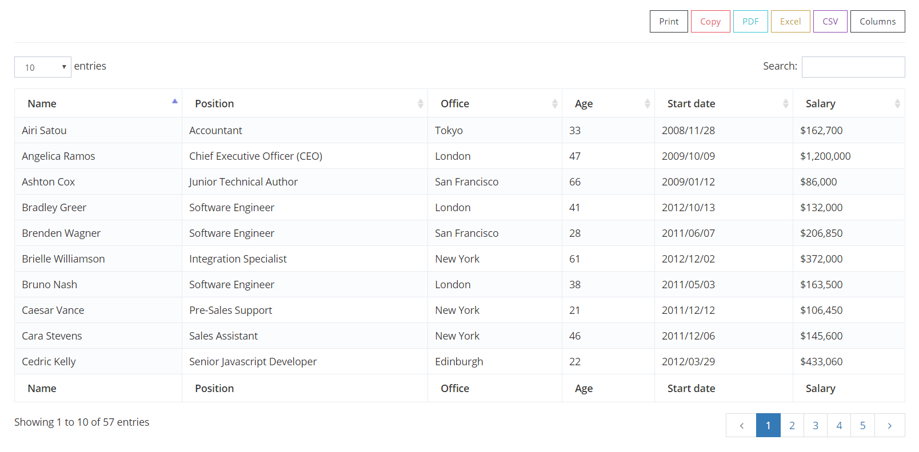Data Tables (With large number of columns)
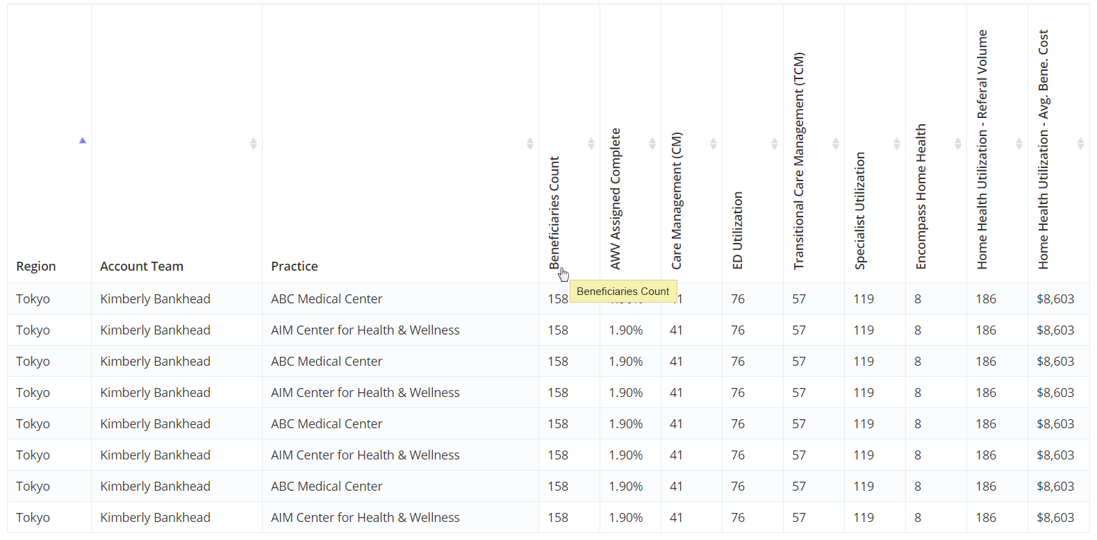

See code examples below:
HTML: 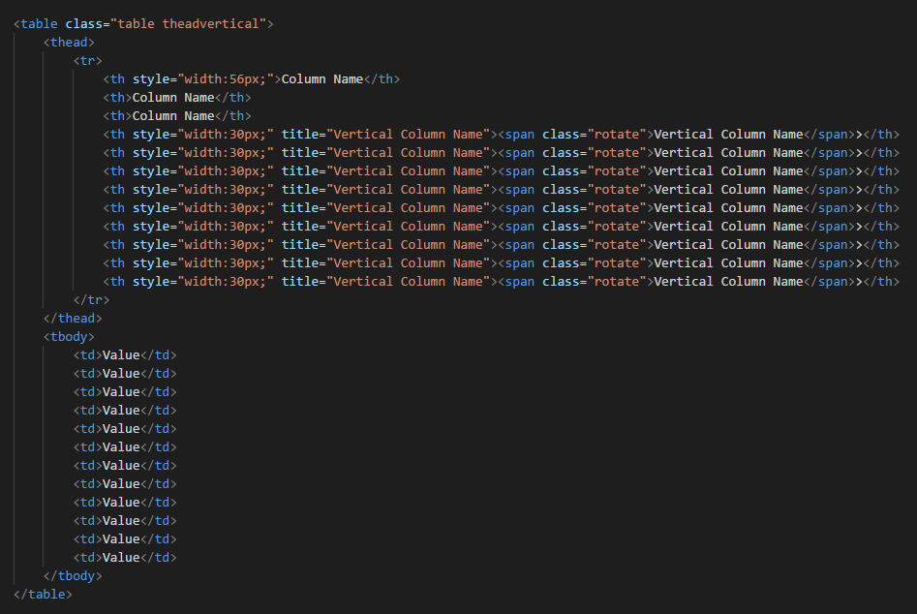
CSS: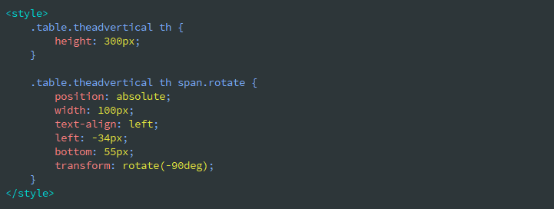

Data Tables (With Child rows)

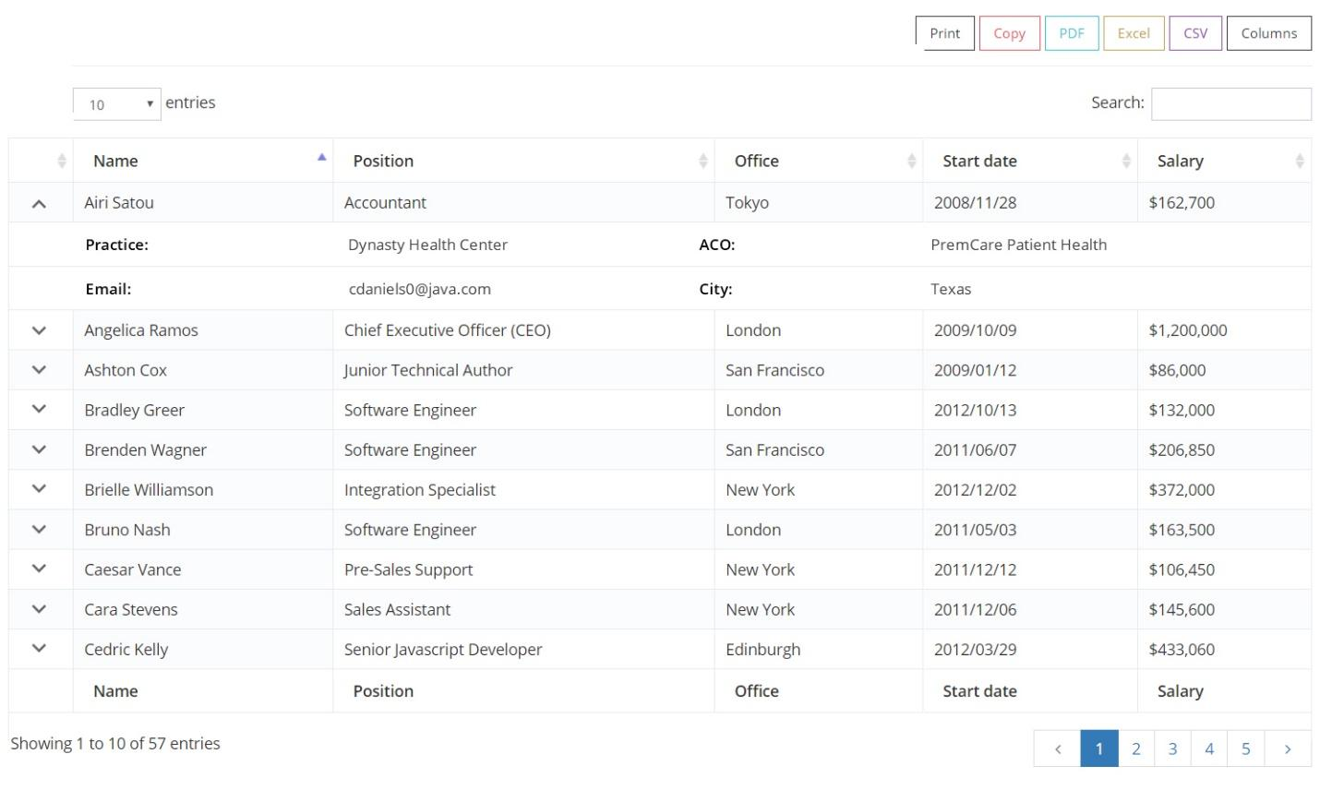

Pagination Styles:
Styles: Font-weight: 300 | Font-Family: Open Sans | Other Styles: Default Bootstrap Styling
Medium: Font Size: 14px
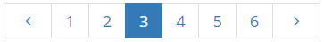

HTML:
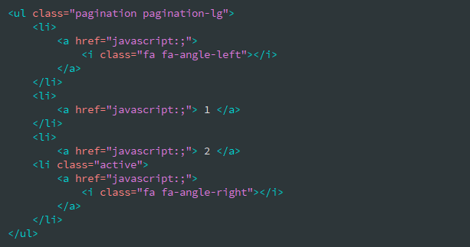

Small: Font Size: 12px
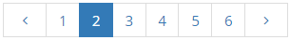

Pagination with First and Last buttons:
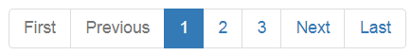

JS Options:
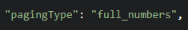

HTML:


